RECIPE  
Cherry Pie

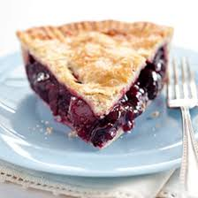

Ready in **20 minutes**

Serves **8 people**

**280 calories**

# Ingredients

* 2 pie crusts
* 5 cups frozen cherries
* 3 tbsp cornstarch
* ⅔ cup granulated sugar
* ½ tsp salt
* 2 tsp vanilla
* ¼ tsp almond extract
* 1 ½ tbsp lemon juice
* 2 tbsp unsalted butter cut into small cubes
* 1 large egg
* 2 tsp water

# Preparation

1. Combine cherries, cornstarch, sugar, salt, vanilla, almond extract, and lemon juice in a large saucepan over medium-high heat.
2. Simmer stirring almost constantly, until the mixture starts to thicken ~ 8 mins
3. Reduce heat to low and cook for another 2 minutes before removing from the heat and allowing to cool
4. Preheat the oven to 425 F
5. Roll out prepared doughs and pour the mixture into the crust
6. Beat the egg and do an egg wash on the top crust
7. Bake the pie for about 15 mins, then reduce the heat to 350 F, covering the crust with a shield and continue baking for 50 mins. Allow to cool and serve.